Project two:

Group partner: Joseph Dailey, Tianqi Nan

Basic requirement:

|  |  |  |  |
| --- | --- | --- | --- |
|  | Requirement: | Who did it: | How it was done: |
| 1 | shader | Tianqi | welcome image on the ground |
|  |  | Joe | Failed |
| 2 | Procedural shader | Tianqi | artistic cube |
|  |  | Joe | Tried (see billboard in TC) |
| 3 | Image texture | Tianqi | Welcome image on the ground |
|  |  | Tianqi | Billboard |
|  |  | Tianqi | Billboard |
|  |  | Joe | Billboard |
|  |  | Joe | Skybox |
|  |  | Joe | multiple sections of the ground |
| 4 | Moving object | Tianqi | Flag |
|  |  | Joe | Propellers supporting platform |
|  |  | Joe | Jet engine supporting platform |
| 5 | Time-varying appearance | Tianqi | The flag will change color during different time |
|  |  | Joe | Weeds are either flowering or budding depending on time  (flower between 6a and 6p) |
| 6 | The curved surface | Tianqi | flag |
|  |  | Joe | Jet engine |
| 7 | Technical change |  | See the next table |

Technical challenge:

|  |  |  |  |
| --- | --- | --- | --- |
|  | Challenges | Who did it: | How it was done: |
| 1 | Surface of revolution | Tianqi | The trees |
|  |  | Joe | Jet |
| 2 | Skybox | Joe | Iceflat images on the inside of a cube |
| 3 | Billboard-failed | Joe | I tried to make the weeds face the camera with a vertex shader or a glrotate but couldn’t |
| 4 | Particle Systems | Tianqi | If you push the meteorites button, you can see it. |
| 5 | Writing your own model loader | Tianqi | I tried and succeed, but it hurt FPS too much so I delete all the codes. But I save a screenshot of the model. You can see it below. |

Some fix and improvement to the project one:

1. Fix the bug that color changes automatically. Now the color will not change.
2. Add a tension slider as GUI.
3. Add a coaster

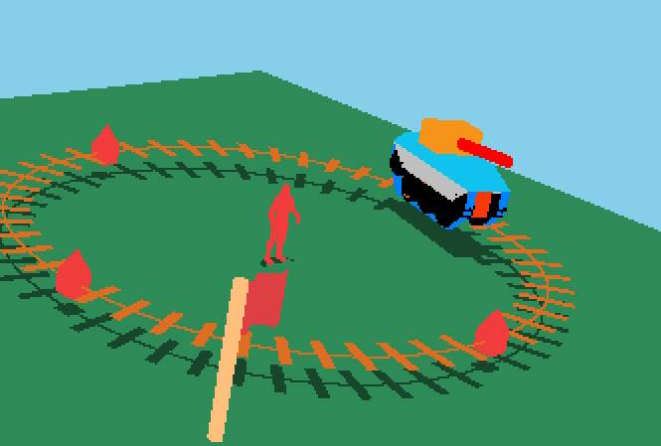

**Picture of project to show off:**

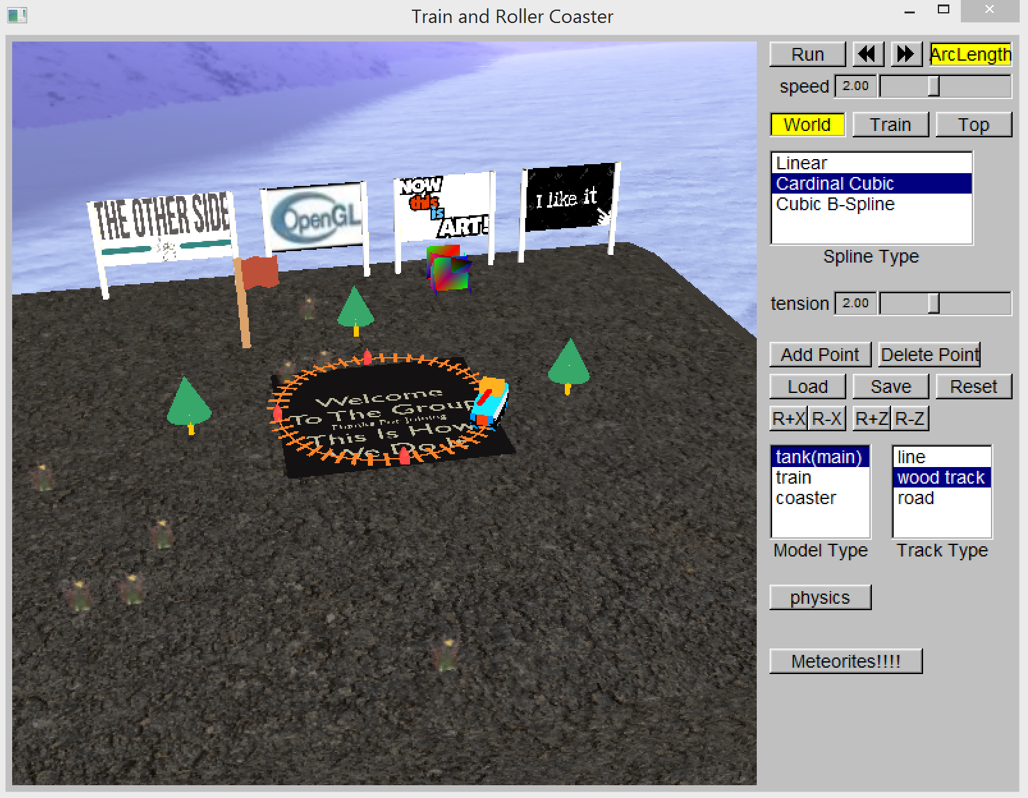

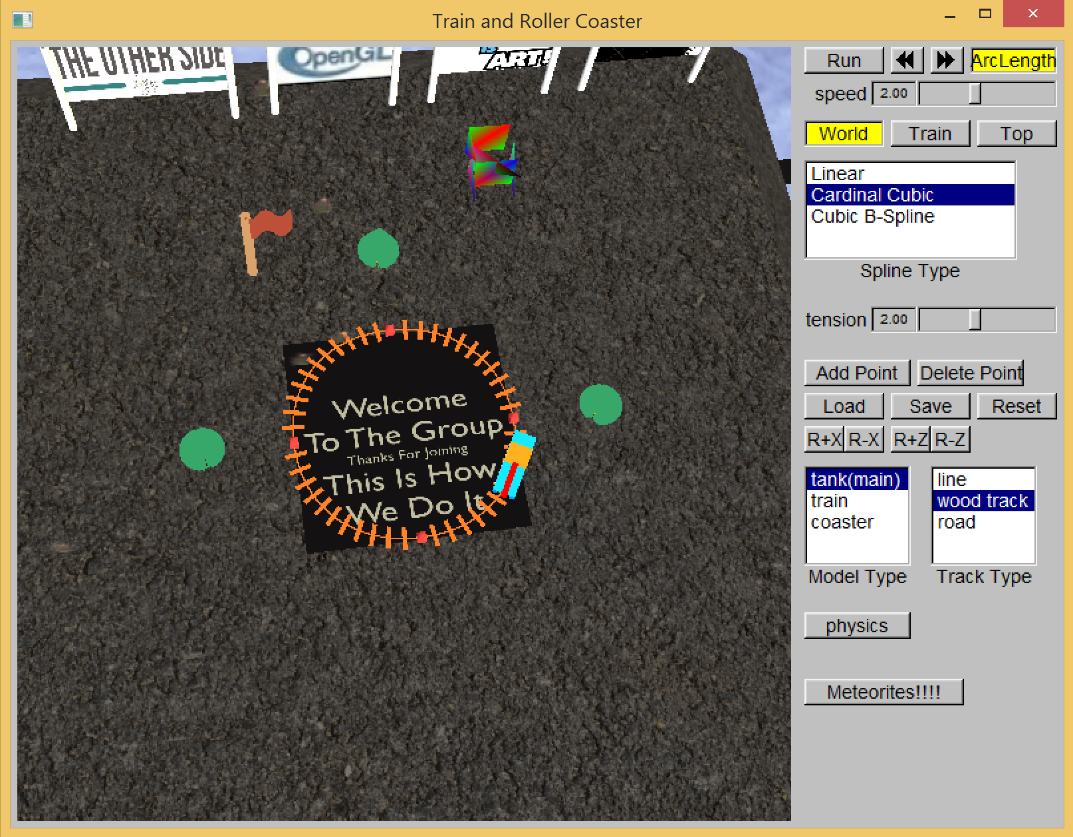

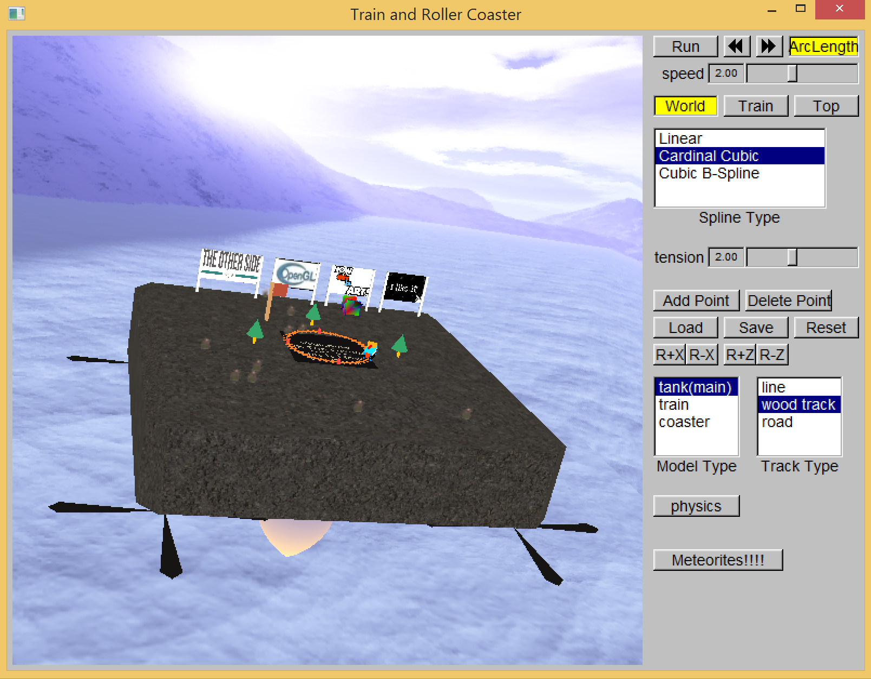

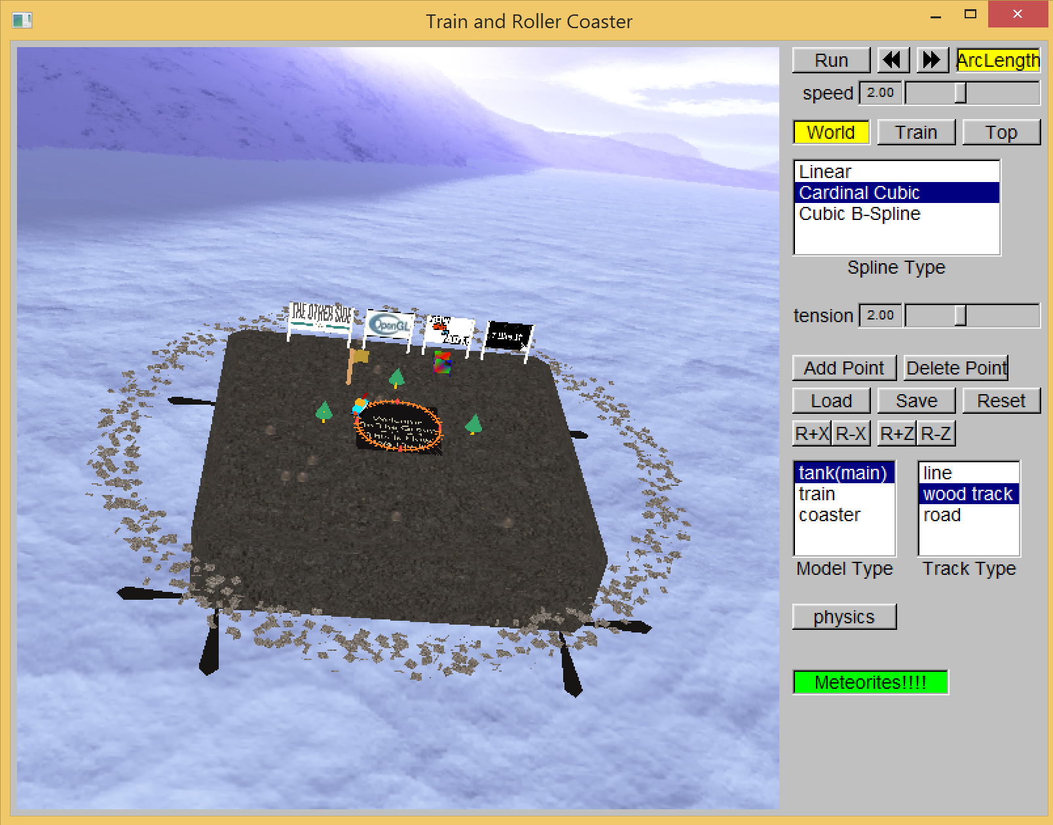

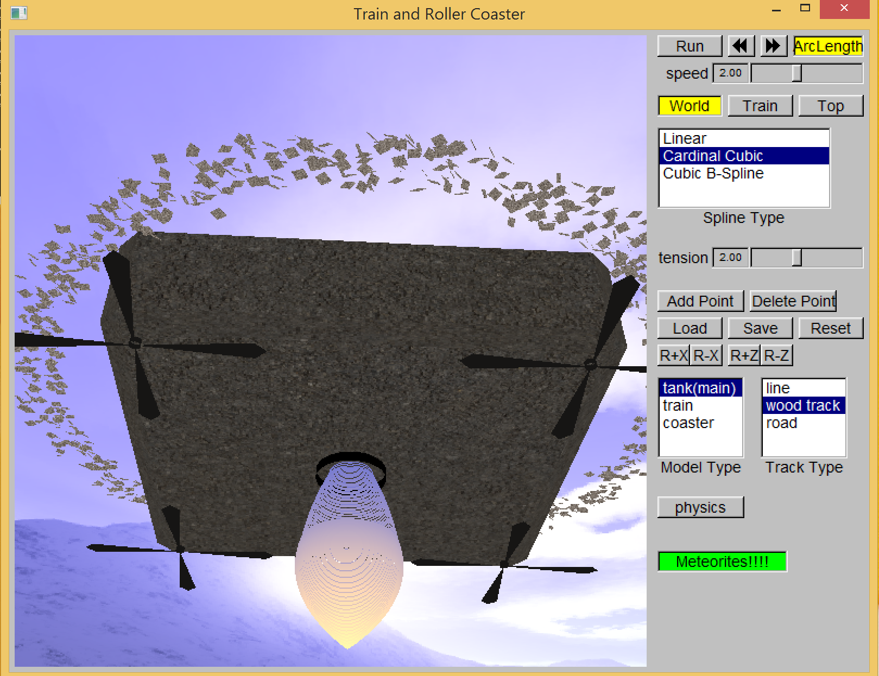

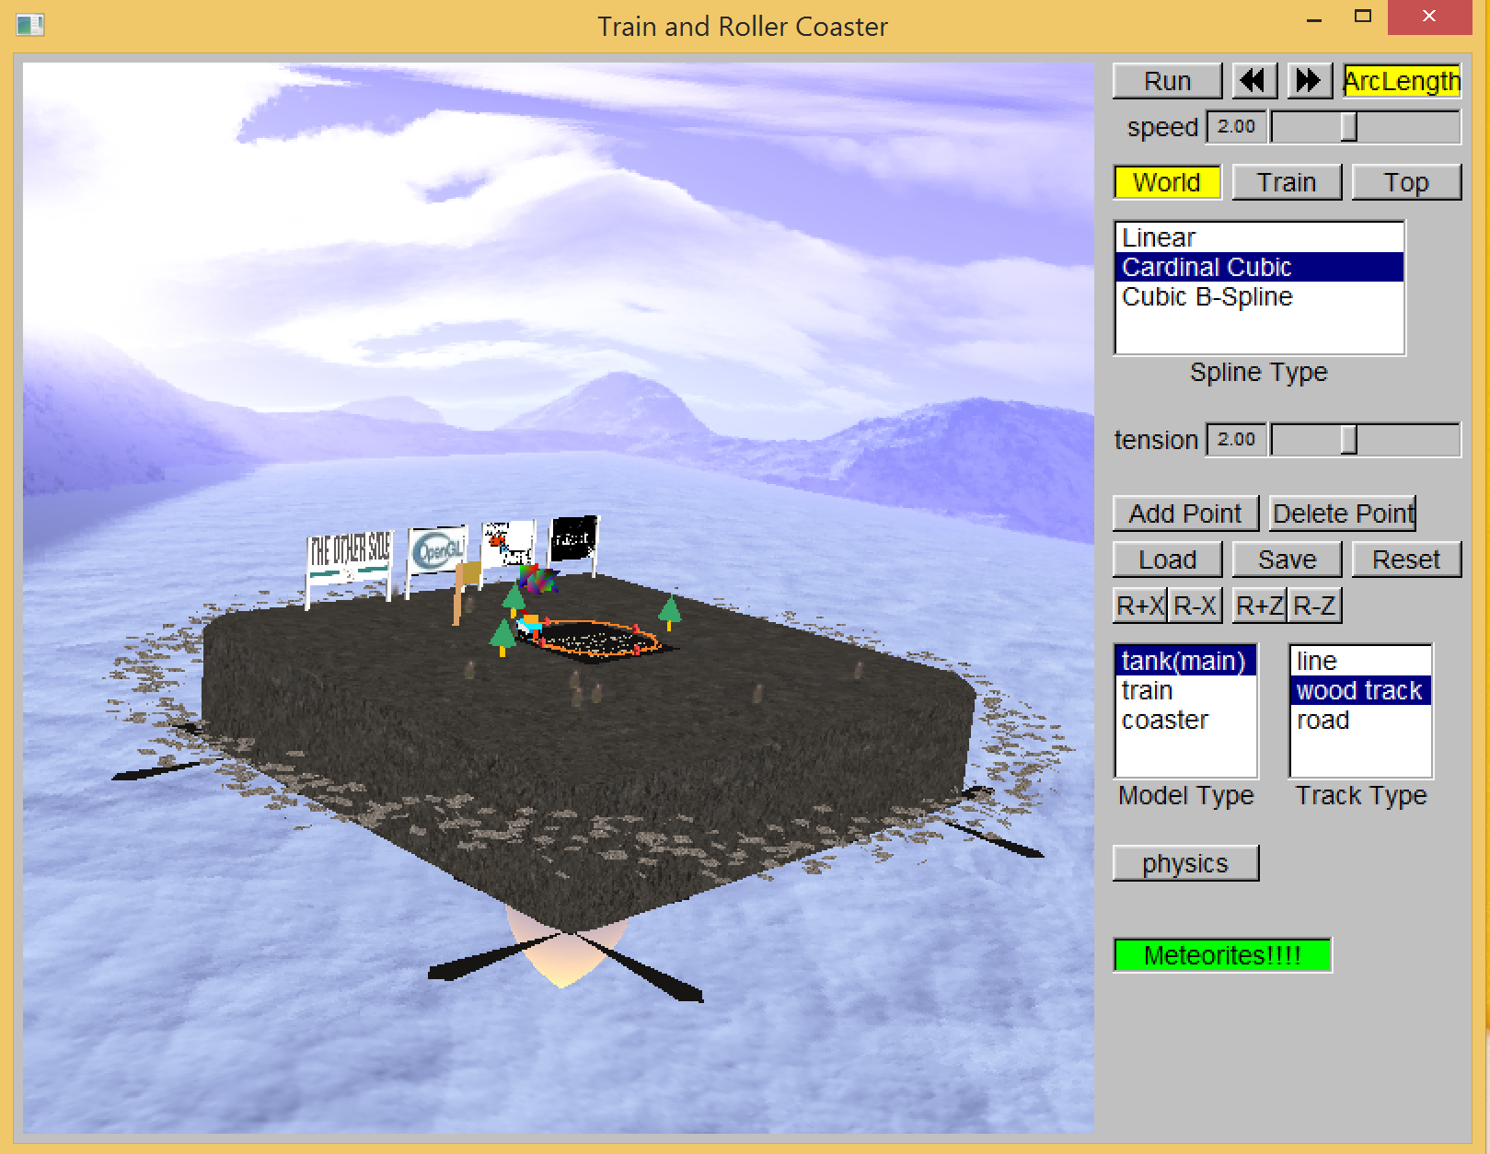

As you can see, we add the skybox. And in order to make the skybox looks harmonize with the ground, we add the jet to let it fly.

We also tried to add some cool models, but due to some unknown reason, it hurt the FPS too much, so we just decide to delete it.

But we successfully add the particle system, make it looks much more cool.

Maybe for this project it is not that perfect, but we two totally pay at least 120 hours on it. Sometimes we can waste the whole afternoon just find the cool things like model, can be imported, but can’t be really used. Those kinds of things take a lot of time and make us feel upset. But still, the process is interesting and exciting. When we finally finish it, it really feels great. If we can have more time, we will definitely do it better. It’s really enjoyable to walk so far from the beginning.

Thanks for grading. ^-^